

Project Name: Dynamic host configuration protocol
Session: 2023-2027
(Reg. No. Applied for)

Submitted to: Sir Bilal
Subject: Computer network
Submitted By:
Hafsa Iftikhar (50),Tayba Rehman (36)

DEPARTMENT OF ARTIFICAL INTELLIGENCE
FACULTY OF COMPUTING AND ENGINEERING
UNIVERSITY OF KOTLI AZAD JAMMU AND KASHMIR

1. Abstract
This project demonstrates how to configure a DHCP server in Cisco Packet Tracer to automatically assign IP addresses, subnet mask, default gateway, and DNS server to client PCs. The goal is to simplify network configuration by automating IP allocation rather than manually assigning addresses to each device.

2. Introduction
In real-world networks, manually giving IP addresses to every device is time-consuming and error-prone especially when devices join or leave the network frequently. The concept of DHCP solves this problem by automatically providing required IP settings to network devices when they connect. In this project, we use Cisco Packet Tracer to simulate a network where a server acts as DHCP server, and a couple of PCs obtain network configuration dynamically. This kind of network can be applied in offices, schools, labs anywhere multiple devices connect and you want to avoid manual configuration.

3. Objectives
- Demonstrate automatic IP address assignment using DHCP.
- Understand configuration of a router/server as a DHCP server and correct usage of DHCP pools.
- Configure client PCs to use DHCP and verify connectivity via ping command or by checking assigned IP.

4. Tools & Software Used
Software | Purpose
Cisco Packet Tracer | Version simulate network topology and DHCP behavior
Server | To act as DHCP server
End-devices (PCs) | Clients that obtain IP configuration from DHCP

5. Network Topology
Topology Type: Simple LAN (one server + switch + multiple PCs) star or basic LAN type.
Topology Description: server connected to switch, switch connected to two PCs. Serve interface acts as default gateway and DHCP server.
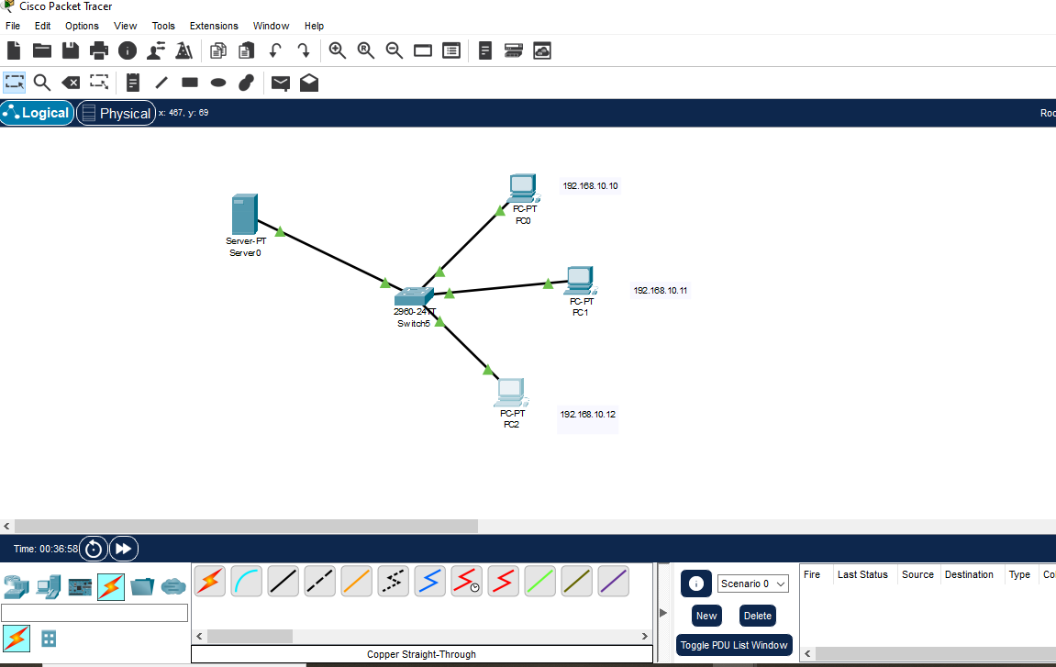

6. Device List
Device | Purpose
Server | Acts as DHCP server and gateway
Switch | Connects server and PCs
PC Client 1 | Receives IP via DHCP
PC Client 2 | Receives IP via DHCP

7. Implementation Steps
- Launch Cisco Packet Tracer and place devices: one server one switch, and two PCs.
- Connect server to switch, and switch to PCs — using automatic (copper) cables.
- On the server: configure interface connected to the switch (e.g. fa0/0) with IP address and bring it up (no shutdown).
- In router global config, create a DHCP pool. Exclude certain addresses if required (e.g. router’s own IP) so they’re not assigned to clients.
- Define in DHCP pool: the network (subnet), default-gateway.
- On each PC: open Desktop → IP Configuration → set to DHCP (instead of static). PC will automatically get IP, subnet mask, gateway, DNS as per DHCP server config.
- To test connectivity: use ping command from one PC to another) to confirm DHCP and network functioning.

8. Simulation & Testing
After configuring DHCP and setting PCs to obtain IP automatically:
- PCs were assigned IP addresses from the DHCP pool (e.g. 192.168.1.11 etc.).
- Default gateway and DNS (if configured) also assigned properly.
- Using ping command between PCs or from PC to router succeeded indicating correct network setup and DHCP working.
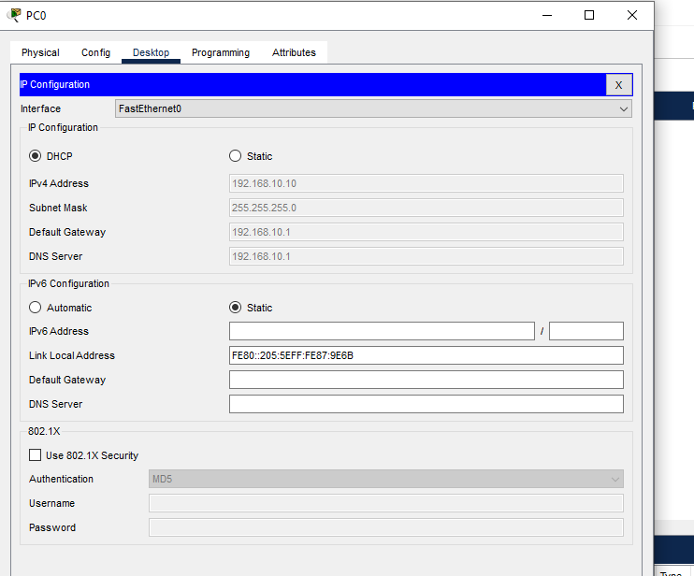
PING SUSSESFULL:
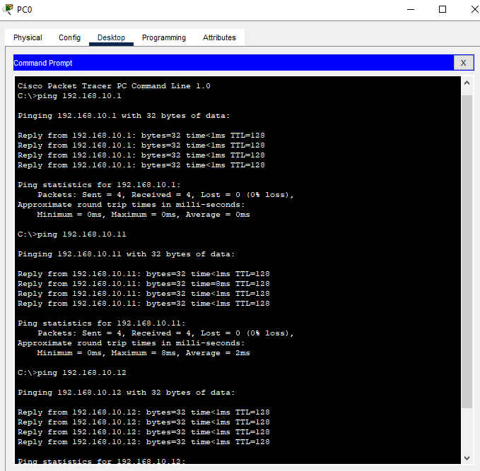

10. Results & Discussion
- Success: Devices received IP configurations automatically. DHCP simplified network setup — no manual IP entry required for each PC.
- Efficiency: For multiple client PCs (now only two), this method is efficient for larger networks.
- Flexibility: If new PC is added later, as long as it’s connected to switch and DHCP enabled, it will automatically gain network settings.
- Potential Problems: If DHCP pool range is small and many devices connect pool may exhaust. Also, DHCP server must be active for clients to get IP.

11. Conclusion
Through this simulation, we learned the power and convenience of DHCP in networks: automated IP allocation, ease of adding devices, and reduced manual errors. In real-world networks (offices, labs) this method saves time and simplifies administration. In future, we can expand this network add more PCs, switches, maybe a second subnet and configure DHCP relay or multiple pools for more complex scenarios.

12. References
- Guide on configuring DHCP server in Cisco Packet Tracer.
- Article summarizing DHCP basics and Packet Tracer steps.
- Information about DHCP protocol and its purpose.

13.GitHub upload project
